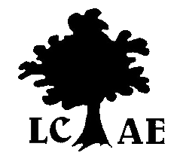
London Council for Adult Education
P.O. Box 51024 Stoneybrook R.O., 1593 Adelaide Street, London ON N5X 4P9
Serving adult learners since 1945.

Proposed Meeting Dates, 2017-2018 as of Aug. 15, 2017
General Meetings, Tuesdays, 12-1 pm

Sept. 12
Oct. 10
Nov. 14
Jan. 9
Feb. 13
Mar. 13
April 10
May 17 | Adult Learner Awards
TBD | AGM

Executive Meetings: Wednesdays, 3 pm
Sept. 27
Nov. 29
Jan. 24
March 28

